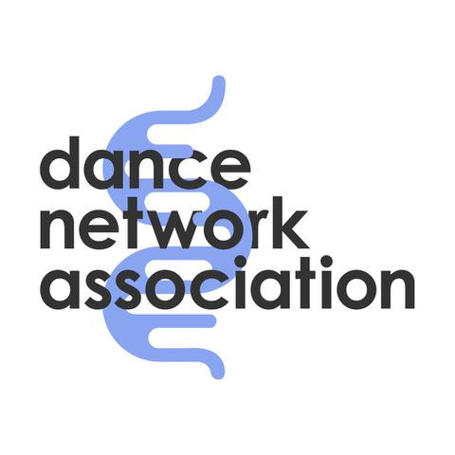

Equal Opportunities Monitoring Form
We are committed to ensuring equality and inclusion across all our activities. To help us monitor and improve our practices, we would appreciate you completing this form. Your answers are confidential, anonymous, and used only for monitoring purposes in accordance with GDPR.
- Your age when completing this form: ___________________________
- Gender identity:
[ ] Man
[ ] Woman
[ ] Non-binary
[ ] Trans man
[ ] Trans woman
[ ] Prefer not to say
If you prefer to self-describe, please specify: _______________________
- Marital or partnership status:
[ ] Single
[ ] Married
[ ] Civil partnership
[ ] Common law/live-in partnership
[ ] Divorced
[ ] Widowed
[ ] Prefer not to say
If you prefer to self-describe, please specify: _______________________
- Sexual orientation:
[ ] Heterosexual / Straight
[ ] Gay
[ ] Lesbian
[ ] Bisexual
[ ] Pansexual
[ ] Asexual
[ ] Queer
[ ] Prefer not to say
If you prefer to self-describe, please specify: _______________________
- Ethnic Background
Please tick the box that best describes your ethnic background.
- White:
[ ] English, Welsh, Scottish, Northern Irish or British
[ ] Irish
[ ] Gypsy or Irish Traveller
[ ] Any other White background
If you prefer to self-describe, please specify: _______________________
- Mixed / Multiple ethnic groups:
[ ] White and Black Caribbean
[ ] White and Black African
[ ] White and Asian
[ ] Any other Mixed background
If you prefer to self-describe, please specify: _______________________
- Asian / Asian British:
[ ] Indian
[ ] Pakistani
[ ] Bangladeshi
[ ] Chinese
[ ] Any other Asian background
If you prefer to self-describe, please specify: _______________________
- Black / African / Caribbean / Black British:
[ ] African
[ ] Caribbean
[ ] Any other Black, African or Caribbean background
If you prefer to self-describe, please specify: _______________________
- Other ethnic group:
[ ] Arab
[ ] Any other ethnic group
If you prefer to self-describe, please specify: _______________________

- Religion or belief:
[ ] No religion
[ ] Atheist
[ ] Agnostic
[ ] Buddhist
[ ] Christian
[ ] Catholic
[ ] Hindu
[ ] Jewish
[ ] Muslim
[ ] Sikh
[ ] Spiritualist
[ ] Prefer not to say
If you prefer to self-describe, please specify: _______________________
- Do you consider yourself to have a disability or long-term condition?
[ ] Yes
[ ] No
[ ] Long-term physical or sensory impairment
[ ] Neurodivergent (e.g. autism, ADHD)
[ ] Mental health condition
[ ] Prefer not to say
If you prefer to self-describe, please specify: _______________________
- Do you have caring responsibilities?
[ ] Primary carer of a child/children under 18
[ ] Primary carer of a disabled child/children
[ ] Primary carer of a disabled adult (18 and over)
[ ] Primary carer of an older person
[ ] Secondary carer (another person carries the main caring role)
[ ] No caring responsibilities
[ ] Prefer not to say
If you prefer to self-describe, please specify: _______________________
- What was the occupation of your main household earner when you were about aged 14?
[ ] Modern professional / managerial
[ ] Clerical / administrative
[ ] Skilled trade or manual work
[ ] Long-term unemployed
[ ] Prefer not to say
If you prefer to self-describe, please specify: _______________________
- Is English your first language?
[ ] Yes
[ ] No
[ ] Prefer not to say

