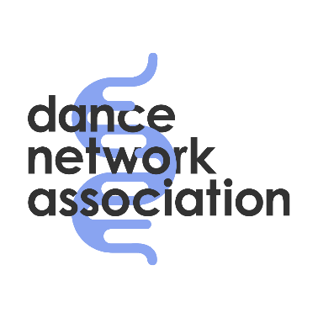

For office use ACCIDENT REPORT REF NUMBER
Participant ID:

DANCE NETWORK ASSOCIATION ACCIDENT REPORT FORM
About the person who had the accident:
Full Name: ___________________
Address:
About you, the person filling in the form:
Full Name: ___________________
Address:
Signature (yours): ________________________________________
Signature (theirs):_________________________________________
When and where did the accident happen: ______
About the accident (what happened?) ______________________________________________________________________________________________________________________________________________________________________
RIDDOR (office use only) | How Reported:
Date Reported: | Employers Name and Initials:

