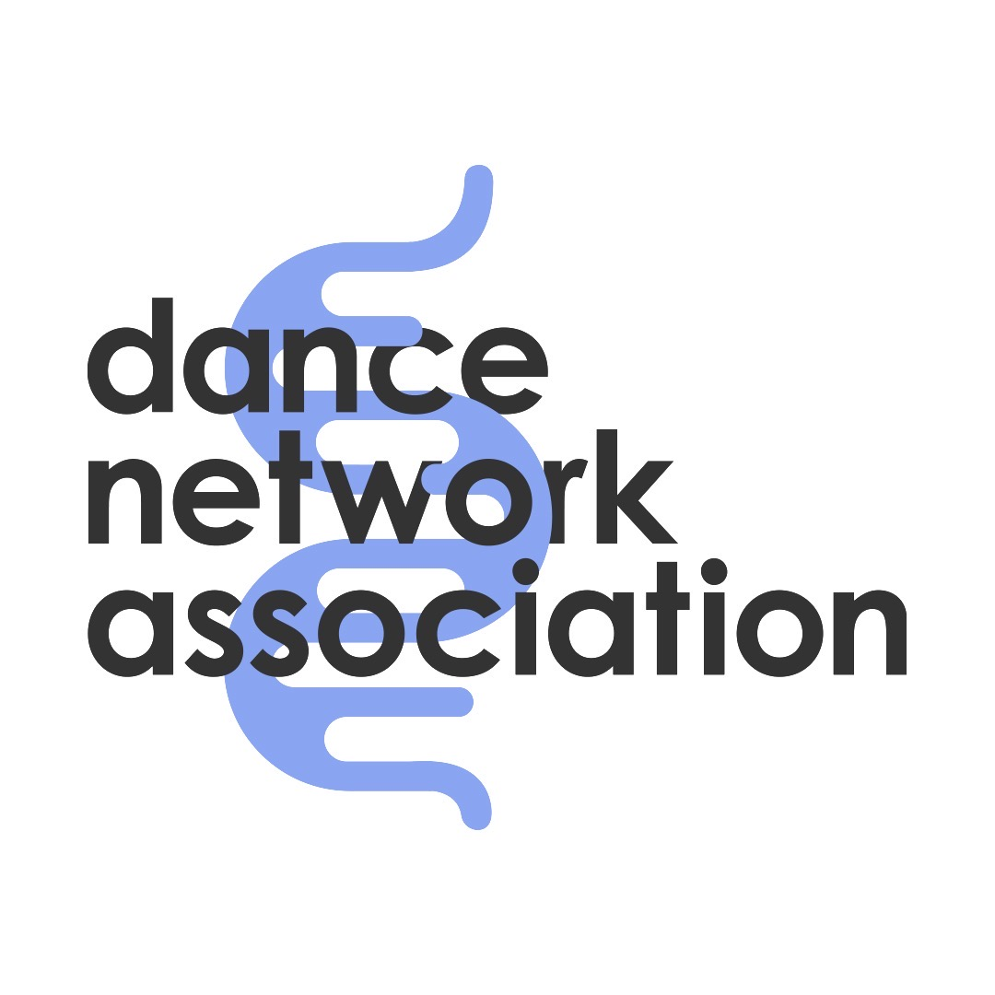

DNA Risk Assessment
Name of Programme – Venue Address
Dance Network Association
Sunspot, Brooklands, Jaywick Sands, Essex, CO15 2JG
T: 07490 374 717 E: info@dancenetworkassociation.org.uk www.dancenetworkassociation.org.uk
Facebook, Instagram and LinkedIn: dancenetworkassociation
Registered Charity No. 1202883

Assessment Details
Location | Address?
Activity | Title of programme/activity?
Date of Assessment | Date?
Time | Times?
Collated by | Who collated?
Date(s) of Activity | Date of activity?
Lead Artist | Lead Artist Name?
Support Artist | Name of Support artist?
First Aider on site | Named of first aider?
Emergency Contact | Gemma Wright 07479 197 993
Safeguarding Contact | safeguarding@dancenetworkassociation.org.uk

Risk Rating Key
Likelihood × Severity = Risk Level
Severity | Likelihood | Overall Risk
Minor | Unlikely | Low
Moderate | Possible | Medium
Major | Likely | High

Risk Assessment Table
For the purposes of this document, the term “staff” refers to all members of the DNA administrative team, Dance Artists, Support Artists, and Volunteers. The term “participants” refers to anyone else present in the space, including dancers, carers, venue staff, and visitors.
Hazard | Potential Outcome | Those at Risk | Risk Rating | Preventive / Control Measures
Example: Slips, trips, and falls | Injury from uneven flooring, rugs, spillages | Participants, staff | Medium | Pre-inspection of space, ensure footwear suitable, walkways clear, chairs available for rest, spillages cleared promptly.

Emergency Response Protocol
• In life-threatening emergencies call 999 immediately.
• For non-life-threatening situations call NHS 111.
• Provide first aid if safe and trained to do so.
• Calm the group and end session if necessary.
• Inform participant’s emergency contact if appropriate.
• Complete an accident/incident report form (in artist box or via DNA website).
• Notify DNA CEO and Board for review and learning.

